Question 1 . Evaluation Value using Logistic Regression

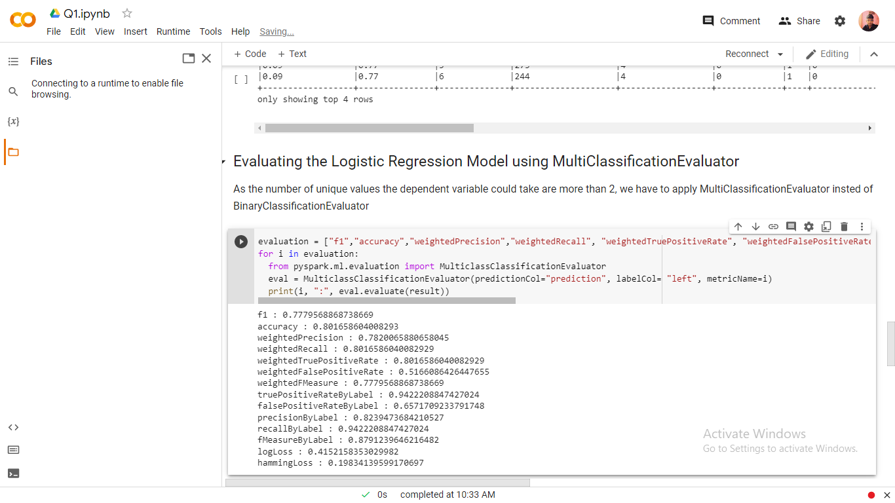

Evaluation Value using Decision Tree Classifier Model

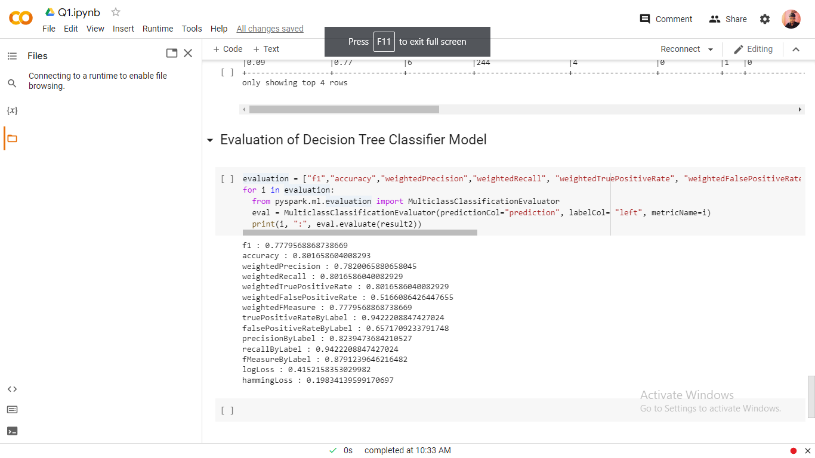

Q2. Evaluate value using Linear Regression Model

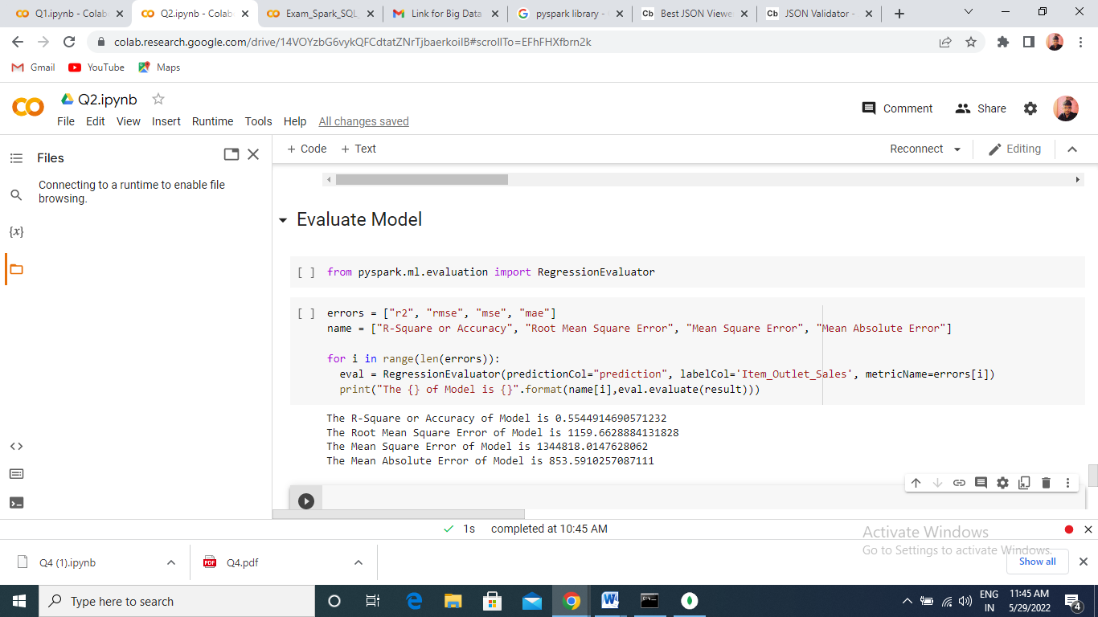

Q3. JSON File Attached

Q4. a

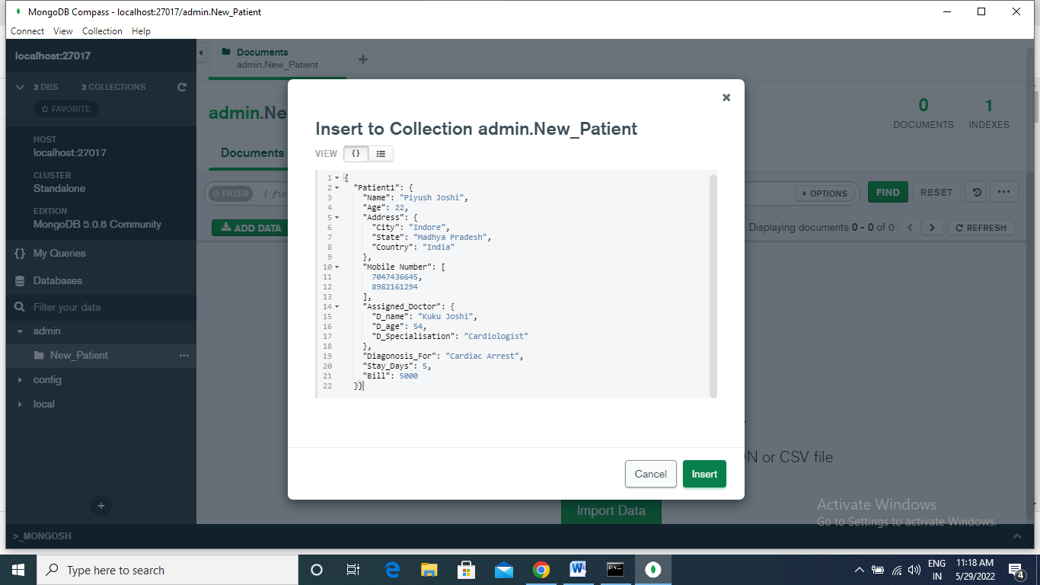

Q4 b

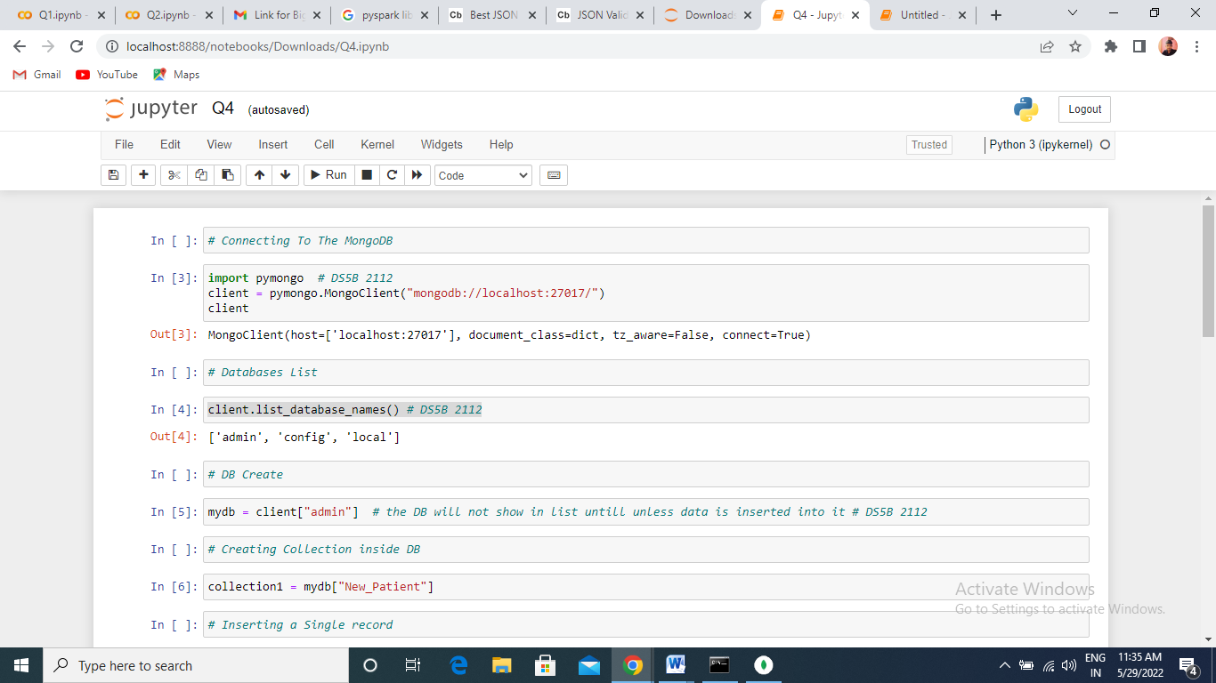

Creating Collection and Inserting Record

Inserting Single Record

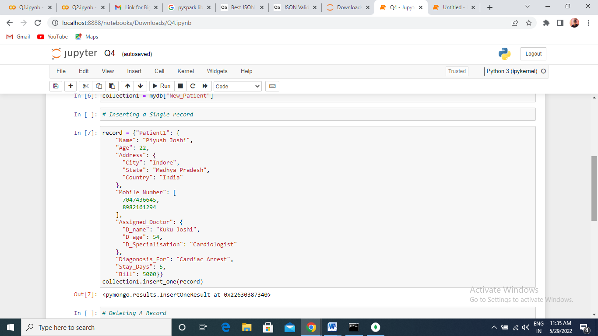

Deleting Record and Updating Record

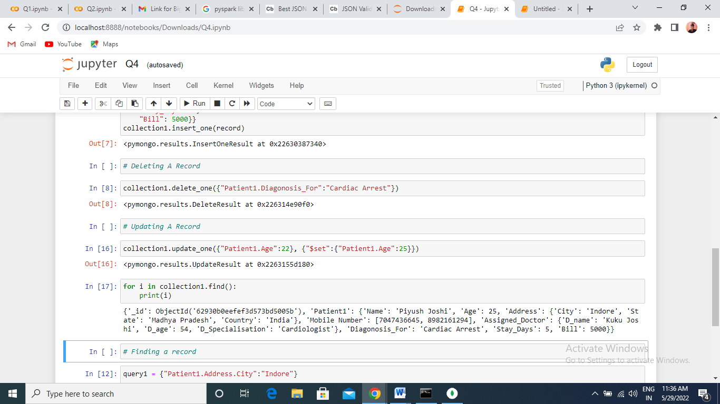

Updated Value inside the Mongo DB Compass

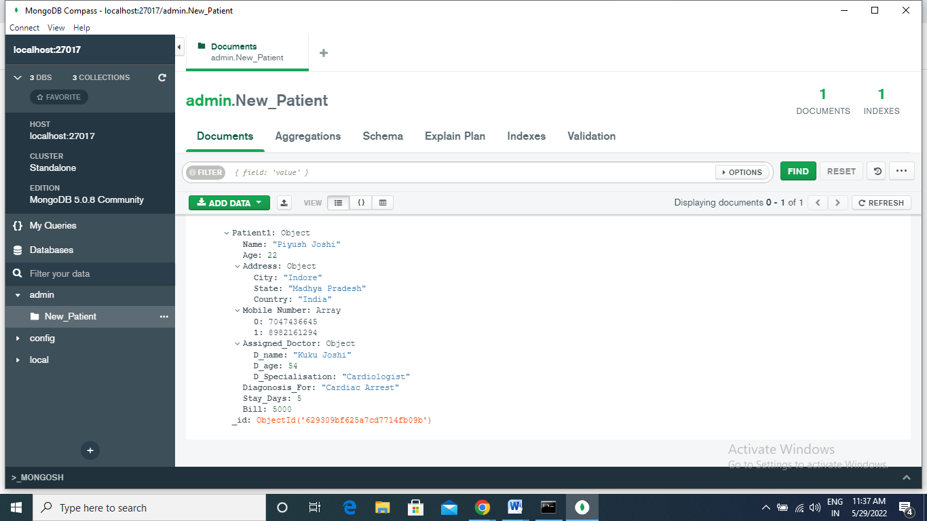

Finding a Record

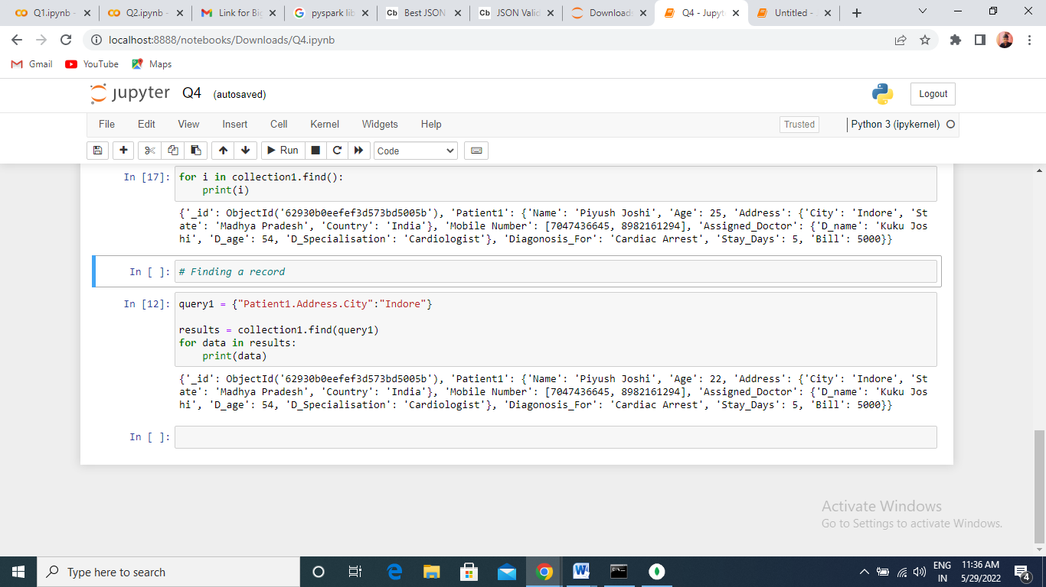

Deleting value using button

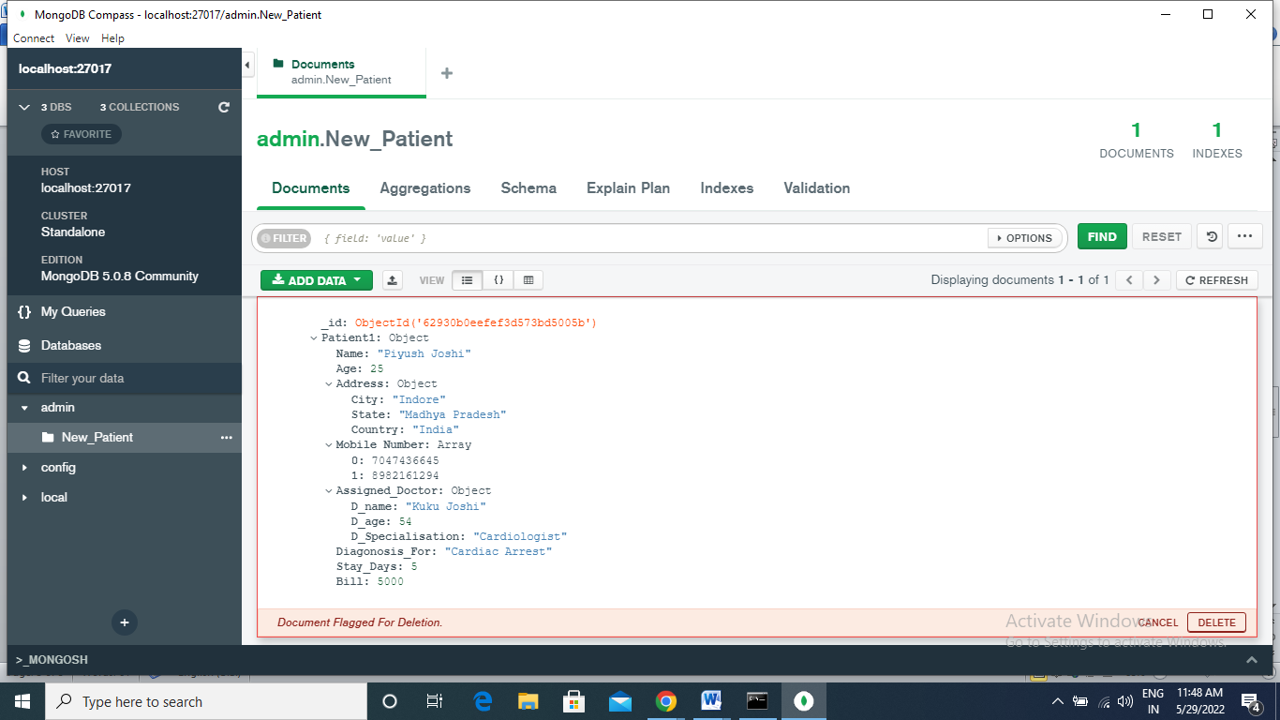

Updated Age Value inside MongoDB 22 to 25

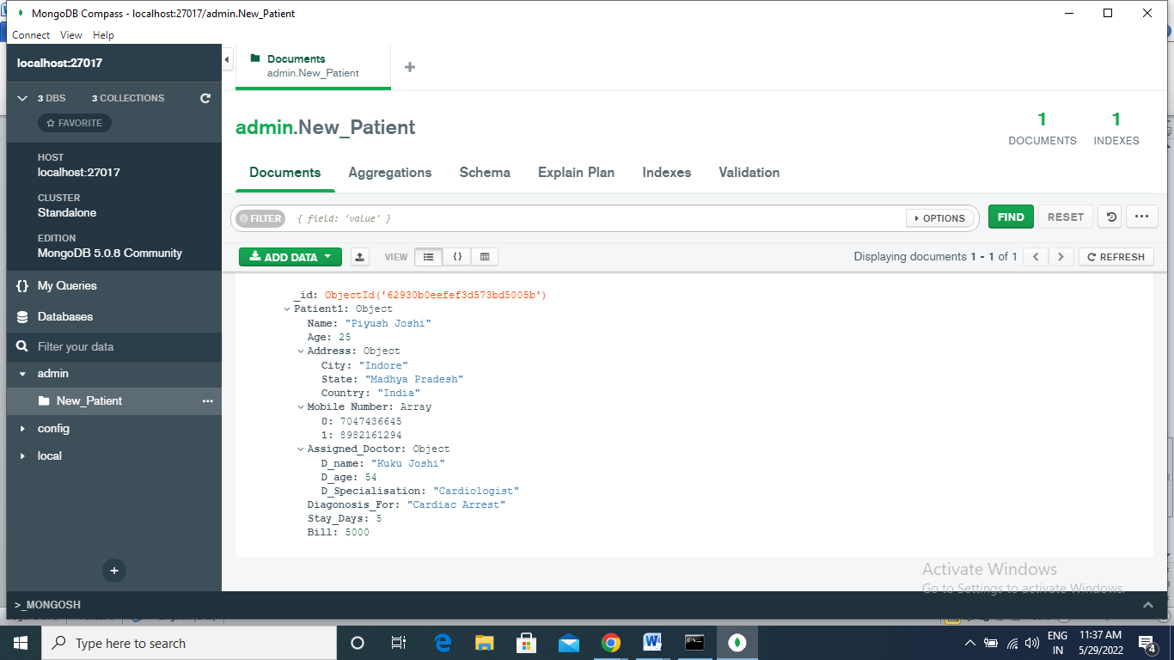

Q5. RDD

Q5. Ipynb file